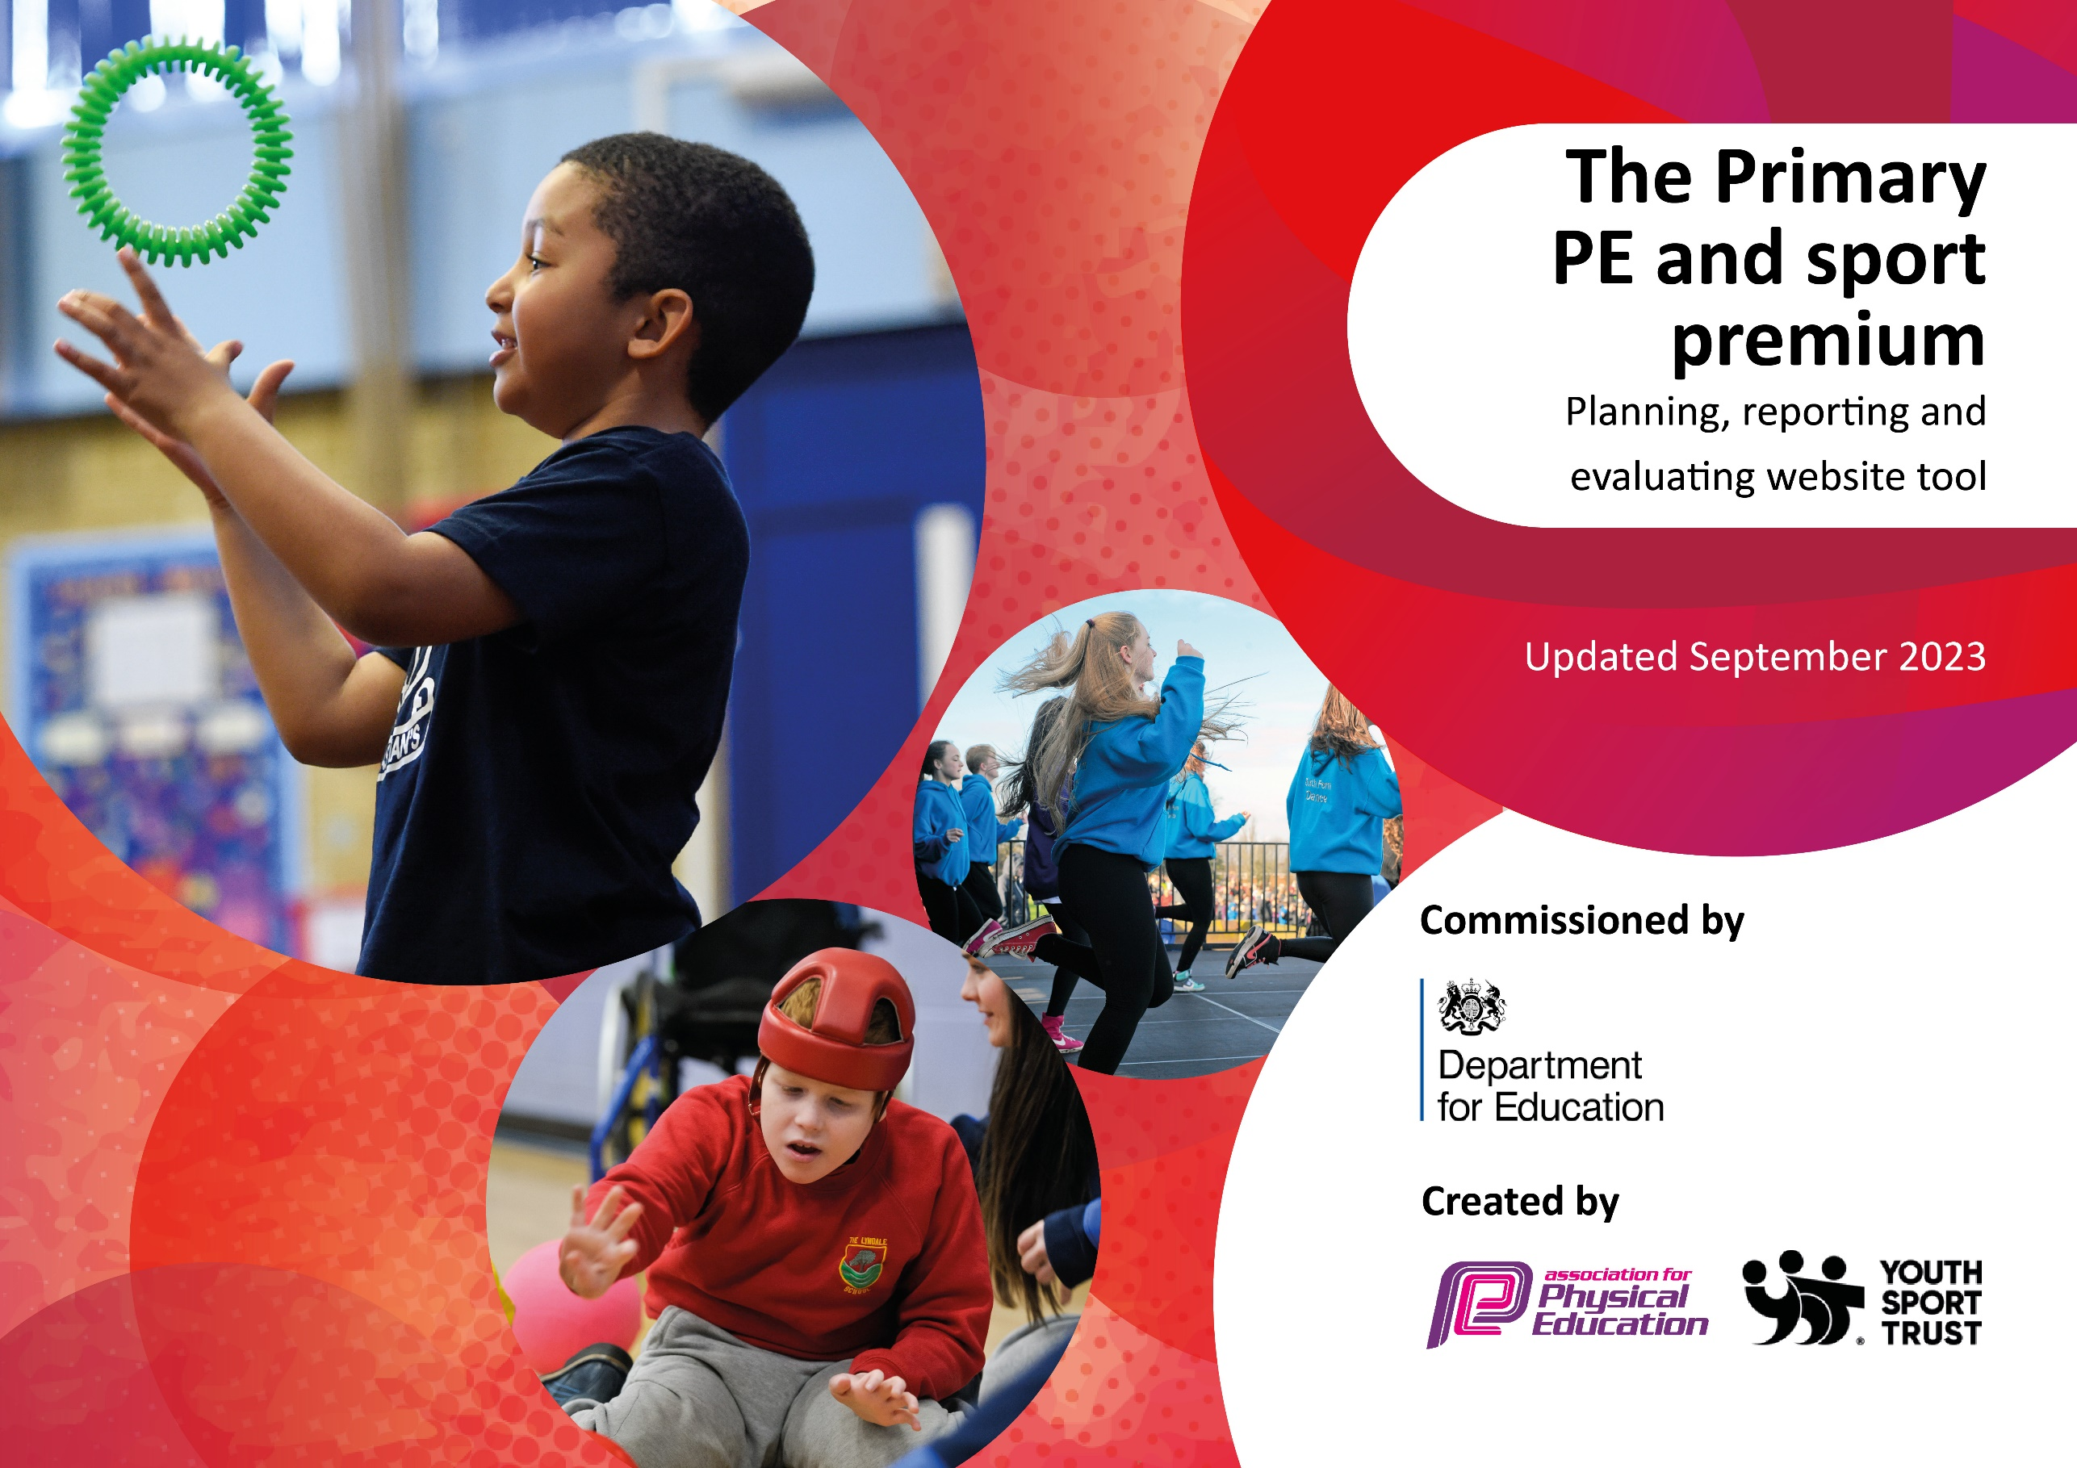

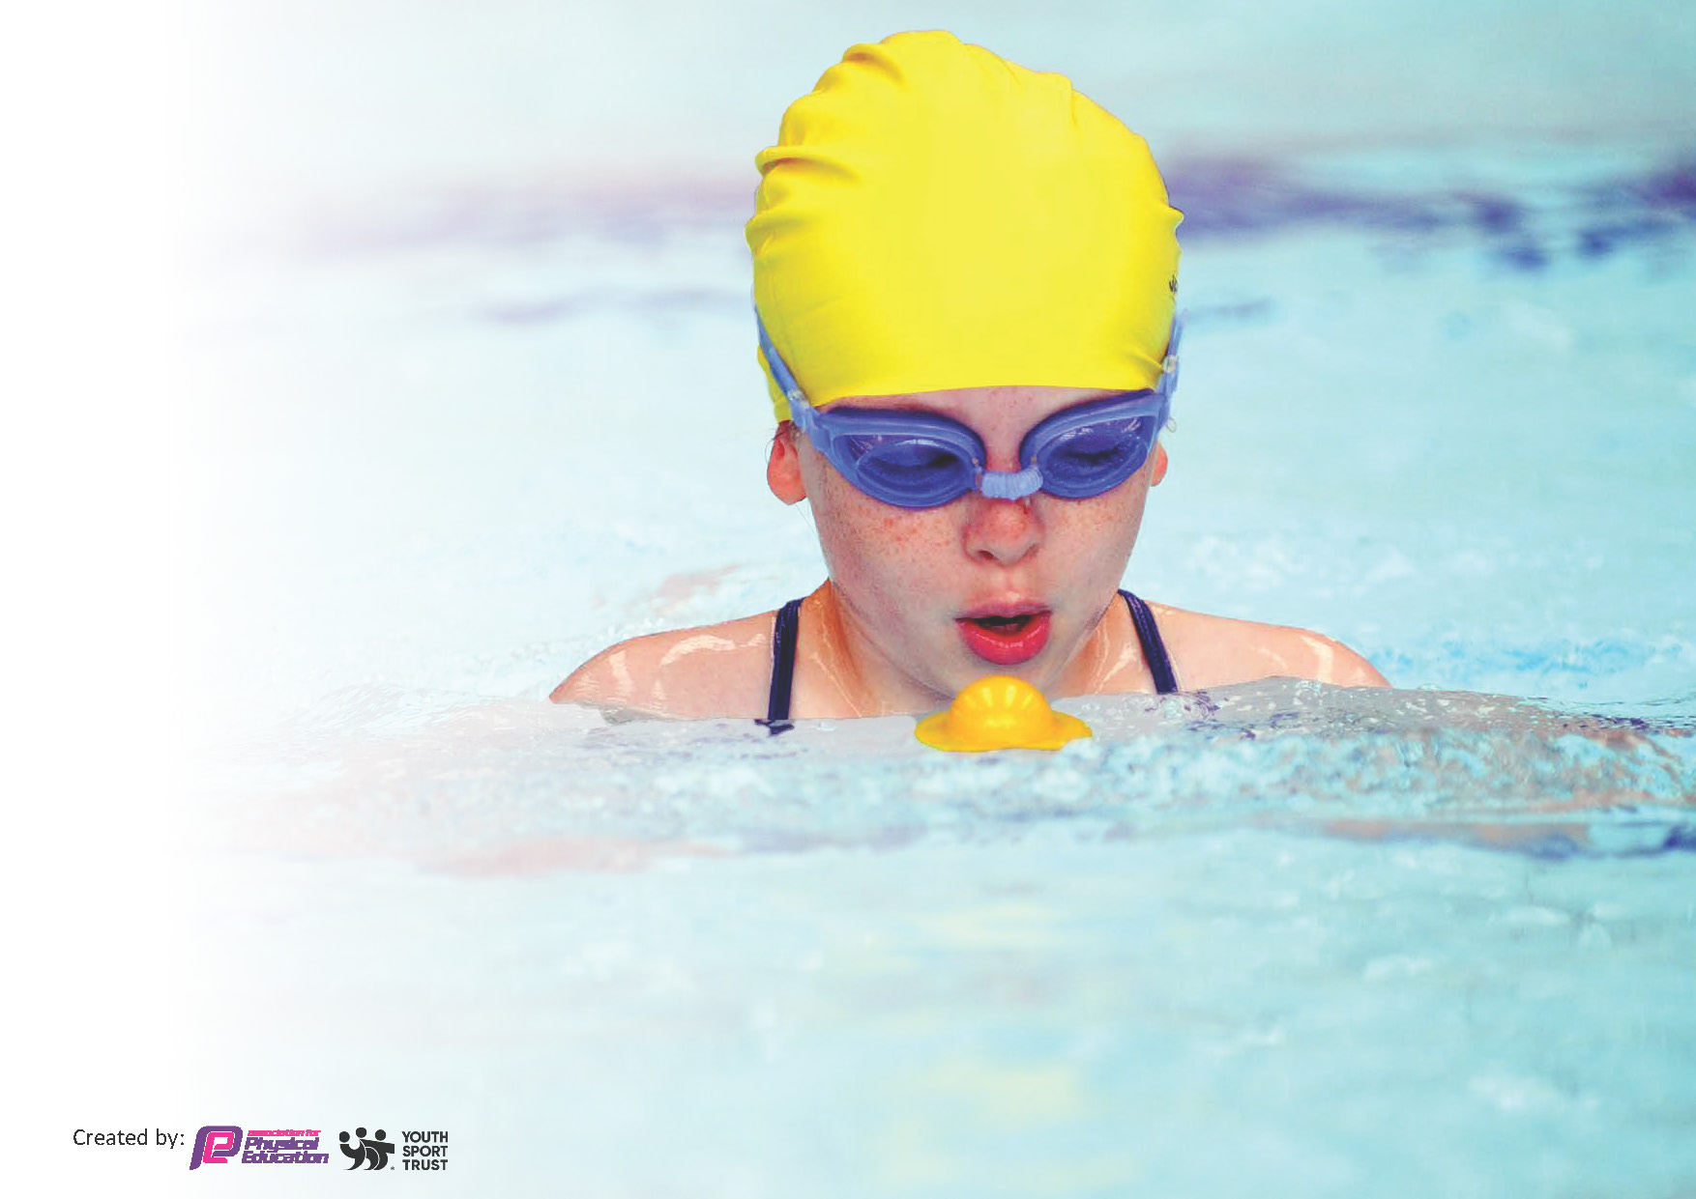
This template can be used for multiple purposes:
by:
- It enables schools to effectively plan their use of the Primary PE and sport premium
- It helps schools to meet the requirements (as set out in guidance) to publish information on their Primary PE and sport premium
- It will be an effective document to support Ofsted inspections enabling schools to evidence progress in Physical Education (PE) and evidence swimming attainment, which forms part of the PE National Curriculum. We would recommend schools consider
the Intent, Implementation and Impact of any spend, as examined within the Education Inspection Framework.

It is important that your grant is used effectively and based on school need.

Schools must use the funding to make additional and sustainable
improvements to the quality of the PE, School Sport and Physical Activity (PESSPA)
they offer. This means that you should use the Primary PE and sport premium to:

- Build capacity and capability within the school to ensure that improvements made now will benefit pupils joining the school in future years
- Develop or add to the PESSPA activities that your school already offers.

The Primary PE and sport premium should not be used to fund capital spend projects; the school’s core budget should fund these. Further detail on capital expenditure can be found in the updated Primary PE and sport premium guidance.

The Primary PE and sport premium guidance, outlines 5 key priorities that funding should be used towards. It is not

necessary that spending has to meet all the key priorities, you should select the priorities that you aim to use any funding towards.

Although completing this template is not a requirement for schools, schools are required to publish details of how they spend this funding. Schools must also outline what the impact this funding has had on pupils’ PE and sport participation and attainment and how any spending will be sustainable in the future. All funding must be spent by 31st July 2024.

The Department for Education has worked closely with the Association for Physical Education (afPE) and the Youth Sport Trust (YST) to develop this template and encourages schools to use it. This template is an effective way of meeting the reporting requirements of the Primary PE and sport premium.
Review of last year’s spend and key achievements (2022/2023)

We recommend you start by reflecting on the impact of current provision and reviewing your previous spend.

Activity/Action | Impact | Comments
Subsidising Year 6 in order for them to access Outdoor Adventurous Activities during summer residential.  Sporting opportunities for children with SENd / athletic disadvantages. | Over 90% of Year 6 children attended the residential in Anglesey.  Over 20% of children accessed sports like darts, bowls at some point in the year, culminating in Spring and Summer competitions. | Through consultations with parents, we found that this was essential again in 2023/24.  Easily accessible activities for children and staff. Maintain next year.

Key priorities and Planning
This planning template will allow schools to accurately plan their spending.

Action – what are you planning to do | Who does this action impact? | Key indicator to meet | Impacts and how sustainability will be achieved? | Cost linked to the action
Maintain leadership opportunities  for Year 5 and 6 Play Leaders to plan and deliver a programme to increase the amount of physical activity at lunchtime through the ‘Active Playground’. Training for pupils to deliver playground games.  Purchase of playground equipment. PE Leader plus EYFS member of staff to observe Play Leaders delivering sessions with KS1 children.  Regular, non-timetabled use of outdoor play / balance equipment. MN to be released to train lunchtime staff and Play/Sports leaders. Purchase of new and up-to-date equipment for PE and after-school clubs.  Increase in all-round fitness and well-being through non-competitive activity: maintenance of outdoor gym equipment for playground.  Development of PE pages of website / Twitter  Celebration of school sporting success - purchase / engraving of trophies. Also whole school ‘Sportsmanship’ medals for Sports Day.  To maintain the profile of Inclusive, ‘less-physical’ competitive sports to increase participation and competition across the school - Replacement of sound equipment, darts, bowls.  Participation in Outdoor Adventurous Activity across the whole of Year 6. Subsidised coach and accommodation to Conwy Centre for 32 pupils inc. Pupil Premium children.  New skills demonstrated to / gained by staff in a range of sports. Arrangement and payment of external PE experts (eg: Tennis, Football) to teach alongside staff to further develop knowledge and skills – purchase of equipment for school and extra-curricular sessions.  Development of Mental Health / links with sport through ELSA programme and resources. Coordination between ELSA staff and MN to identify children with MH needs and provide training for physical activity to support.  To offer a wide range of extra-curricular activities for children - Freddie Fit sessions; Prenton Tennis Club; Cross Country Club sessions.  To continue to offer ‘less-athletic’ competitive sport in line with ‘Change for Life’ – purchase of new darts, table tennis equipment.  To provide children with basic First Aid training - L. Evans – St John Ambulance to deliver basic first aid sessions across KS2.  Continue to enter TRFC / Houlihan / Corgi Cup (football) / Birkenhead South Cluster / Wirral School Games competitions (various sports) - release time to travel and coach team.  Increase participation in intra-school competition, with a focus on KS1.  Maintain and attend all events in ‘Birkenhead South PE Cluster’ competitions and tournaments calendar.  All pupils to practise track and field – running track on field marked out and maintained. | Year 6 Play Leaders; KS1 children; Mid-Day Assistants.  PE lead; Year 6 Play Leaders; KS1 children; Mid-Day Assistants.  Year 6 Play Leaders; all KS2 children; Mid-day Assistants.  All children and staff.  PE Lead.  PE Lead; all staff and children.  SENd children, PE Lead.  Year 6 children and staff, PE Lead, accompanying TA.  External providers; all staff and children.  Mrs Langan (ELSA), Mrs Dyas-Ward (SENdCo), PE Lead.  External providers; all children and staff.  SENd children, PE Lead.  Mrs. Evans (St. John’s Ambulance); Year 6 children and staff.  External providers; children selected to represent the school; PE Lead.  Birkenhead South Cluster of PE Leads; all children selected for competition.  All children and staff across the school. | Key Indicator 1: Increased confidence, knowledge, and skills of all staff in teaching PE and sport.  Key indicator 2 -The engagement of all pupils in regular physical activity – the Chief Medical Officer guidelines recommend that all children and young people aged 5 to 18 engage in at least 60 minutes of physical activity per day, of which 30 minutes should be in school.  Key indicator 4: Broader experience of a range of sports and activities offered to all pupils.  Key Indicator 1: Increased confidence, knowledge, and skills of all staff in teaching PE and sport.  Key indicator 2 -The engagement of all pupils in regular physical activity – the Chief Medical Officer guidelines recommend that all children and young people aged 5 to 18 engage in at least 60 minutes of physical activity per day, of which 30 minutes should be in school.  Key Indicator 3: Profile of PE and sport is raised across the school as a tool for whole-school improvement.  Key Indicator 3: Profile of PE and sport is raised across the school as a tool for whole-school improvement  Key indicator 4: Broader experience of a range of sports and activities offered to all pupils.  Key Indicator 3: Profile of PE and sport is raised across the school as a tool for whole-school improvement  Key indicator 4: Broader experience of a range of sports and activities offered to all pupils.  Key indicator 4: Broader experience of a range of sports and activities offered to all pupils.  Key indicator 5: Increased participation in competitive sport.  Key Indicator 3: Profile of PE and sport is raised across the school as a tool for whole-school improvement  Key Indicator 1: Increased confidence, knowledge, and skills of all staff in teaching PE and sport.  Key indicator 4: Broader experience of a range of sports and activities offered to all pupils.  Key indicator 5: Increased participation in competitive sport.  Key indicator 4: Broader experience of a range of sports and activities offered to all pupils.  Key indicator 5: Increased participation in competitive sport.  Key indicator 5: Increased participation in competitive sport.  Key indicator 5: Increased participation in competitive sport.  Key indicator 2 -The engagement of all pupils in regular physical activity – the Chief Medical Officer guidelines recommend that all children and young people aged 5 to 18 engage in at least 60 minutes of physical activity per day, of which 30 minutes should be in school.  Key indicator 4: Broader experience of a range of sports and activities offered to all pupils. | All pupils in KS2 accessing exercise equipment both at break and during outdoor PE session.  All KS2 pupils with opportunity to use play equipment at lunchtime / breaktime / PE time. Maintain for 2024/25.  Positive take-up and feedback from bowls supervisors after sports day.  Continuing purchasing of new outdoor equipment to ensure increased physical activity  Website updated termly  Maintenance of ‘trophy area’ in front foyer, celebrating achievements. Maintain for 2024/25.  Continuation in popularity of darts championship – past pupils returning. Increase rounds in next year’s tournament – continue to focus on less-active children.  Ensured that all 93% of pupils (inc Pupil Premium) in Year 6 were able to access the OAA strand of the curriculum in the summer term by visiting the Conwy Centre in Anglesey. Liaise with local secondary school (SJP) to determine whether we book Conwy again for 2024/25 or look elsewhere (decision to be made before October half-term to enable parents to save).  Regular slots for, Tennis (Prenton TC) and Football (TRFC)– coaches fully integrated into the school with selected school staff able to cover for lateness, introduce skills in their own curriculum-time lessons. Maintain links for 2024/25.  Development of ‘Sensory Corridor’ alongside ELSA staff (M. Langan) and SENdCo (C. Ward). Replenish materials and maintain for 2024/25.  Every child in the school attended a ‘Spring Fitness’ session with Freddie Fit.  Children from every class from Y3 –Y6 with the opportunity to access after-school clubs. Maintain links with current providers and develop others (liaise with Birkenhead South PE Leads Cluster and Wirral Games Leads)  Over 20% of children participated in these sports during 2024/25.  All children in Year 6 attended course delivered by L. Evans.  Competed in Wirral Schools Houlihan Cup; Corgi Cup (Y5 and Y5 tournaments), TRFC girls and mixed competitions; various Birkenhead South Cluster competitions. Re-enter tournaments for 2024/25.  Increase number of competitions through different sports next year.  Successful ‘Paris 2024’ themed Sports Days – all children including KS1 in French-themed teams competing for the shield – Pompidou winners. Annual meeting with Birkenhead South Cluster PE Co-ordinators (Sept 24) to create competition calendar for 2024/25.  Every child (EYFS – Y6) able to access running track in curriculum time and in intra-school competition. Liaise with office / gardeners 2024/25. | £1800  £1300  £500  £1300  £270  £850  £180  £2400  £3700  £2400  £1360  £340  £394  £470  £800  £740

Key achievements 2023-2024
This template will be completed at the end of the academic year and will showcase the key achievements schools have made with their Primary PE and sport premium spending.

Activity/Action | Impact | Comments
Maintain leadership opportunities  for Year 5 and 6 Play Leaders to plan and deliver a programme to increase the amount of physical activity at lunchtime through the ‘Active Playground’. Training for pupils to deliver playground games.  Purchase of playground equipment. PE Leader plus EYFS member of staff to observe Play Leaders delivering sessions with KS1 children.  Celebration of school sporting success - purchase / engraving of trophies. Also whole school ‘Sportsmanship’ medals for Sports Day.  To maintain the profile of Inclusive, ‘less-physical’ competitive sports to increase participation and competition across the school - Replacement of sound equipment, darts, bowls.  Participation in Outdoor Adventurous Activity across the whole of Year 6. Subsidised coach and accommodation to Conwy Centre for 32 pupils inc. Pupil Premium children.  Development of Mental Health / links with sport through ELSA programme and resources. Coordination between ELSA staff and MN to identify children with MH needs and provide training for physical activity to support.  To provide children with basic First Aid training - L. Evans – St John Ambulance to deliver basic first aid sessions across KS2.  All pupils to practise track and field – running track on field marked out and maintained. | All pupils in KS2 accessing exercise equipment both at break and during outdoor PE session.  Maintenance of ‘trophy area’ in front foyer, celebrating achievements.  Continuation in popularity of darts championship – past pupils returning.  Ensured that all 93% of pupils in Year 6 were able to access the OAA strand of the curriculum in the summer term by visiting the Conwy Centre in Anglesey.  Development of ‘Sensory Corridor’ alongside ELSA staff (M. Langan) and SENdCo (C. Ward).  All children in Year 6 attended course delivered by L. Evans.  Every child (EYFS – Y6) able to access running track in curriculum time and in intra-school competition.  Every child in the school attended a ‘Spring Fitness’ session with Freddie Fit.  Children from every class from Y3 –Y6 with the opportunity to access after-school clubs.  Successful ‘Paris 2024’ themed Sports Days – all children including KS1 in French-themed teams competing for the shield – Pompidou winners. | 2024/25: source alternative providers of quality, inexpensive sports equipment. Y6 monitors to store and ensure equipment is safe and looked after.  Regular pupil voice to ensure children are happy and engaging with the programme of clubs and develop further.  Y6 to be trained to create exciting and age appropriate physical games Sept 2024/25.  We will Continue to develop outdoor equipment.  Increase rounds in next year’s tournament – continue to focus on less-active children.  Liaise with local secondary school (SJP) to determine whether we book Conwy again for 2024/25 or look elsewhere (decision to be made before October half-term to enable parents to save).  Maintain for 2024/25.  Maintain for 2024/25.  Maintain links with current providers and develop others (liaise with Birkenhead South PE Leads Cluster and Wirral Games Leads)  Continue in 2024/25.  Re-enter tournaments for 2024/25.  Increase number of competitions through different sports next year.  Annual meeting with Birkenhead South Cluster PE Co-ordinators (Sept 24) to create competition calendar for 2024/25.

Swimming Data
Meeting National Curriculum requirements for swimming and water safety.
Priority should always be given to ensuring that pupils can perform safe self-rescue even if they do not fully meet the first two requirements of the National Curriculum programme of study

Question | Stats: | Further context  Relative to local challenges
What percentage of your current Year 6 cohort can swim competently, confidently and proficiently over a distance of at least 25 metres? | 34% | We have found that this year, the pool we use has only been able to provide two instructors, rather than three. This has led to larger groups where non-swimmers have been slower to make progress.
What percentage of your current Year 6 cohort can use a range of strokes effectively [for example, front crawl, backstroke, and breaststroke]? | 57% | Up from 49% last year. We will communicate with parents the importance of swimming during the summer holidays to increase further next year.

What percentage of your current Year 6 cohort are able to perform safe self-rescue in different water-based situations? | 34% | Roughly in line with National Average. We will communicate with parents the importance of swimming during the summer holidays to increase further next year.
If your schools swimming data is below national expectation, you can choose to use the Primary PE and sport premium to provide additional top-up sessions for those pupils that did not meet National Curriculum  requirements after the completion of core lessons. Have you done this? | Yes/No | Children unable to swim 25m will be targeted and, following consultation with SLT, potentially take those Year 6s in our first block booking of the next academic year. We will then be able to spot gaps in the data and take children who need further lessons again. This will give the children a better chance of achieving 25m.
Have you provided CPD to improve the knowledge and confidence of staff to be able to teach swimming and water safety? | Yes/No | We have employed a teacher who is also a swimming instructor. We will enquire with staff on who would like to take up the teachers’ swimming certificate in Autumn 2025.

Signed off by:

Head Teacher: | Alexander Turner
Subject Leader or the individual responsible for the Primary PE and sport premium: | Matt Nayland – PE Lead
Governor: | (Name and Role)
Date: | 16th July 2024

